ESAA COUNRTY CUP RESULTS PROGRAMME INSTRUCTIONS
When you receive the email with the Excel results programme, DO NOT OPEN FROM THE EMAIL, please save to a folder of your choice, AND SAVE AS MACRO-ENABLED WORKBOOK, the macros are safe to use.
When you open the programme go to the Venue Set-Up tab, the cells that you need to fill in are B2–B8, then the race organisers details in cells B23-B25. And the race distance E2–E7 (and entered in metres as per the example already entered).
When you have completed this, then go to the event tab (which is the same as the one on the declaration sheet). Please fill this in using the same data as you entered on the declaration sheet. For example Bib Numbers and School ID’s.
When you have received all entries back and saved them in a folder of your choice (so they can be found easily).
DECLARATIONS MUST NOE BE COPIED AND PASTED INTO THE RESULTS PROGRAMME.
Then you will be able to import them using the yellow button that says click here to import entries, see screen shots below.
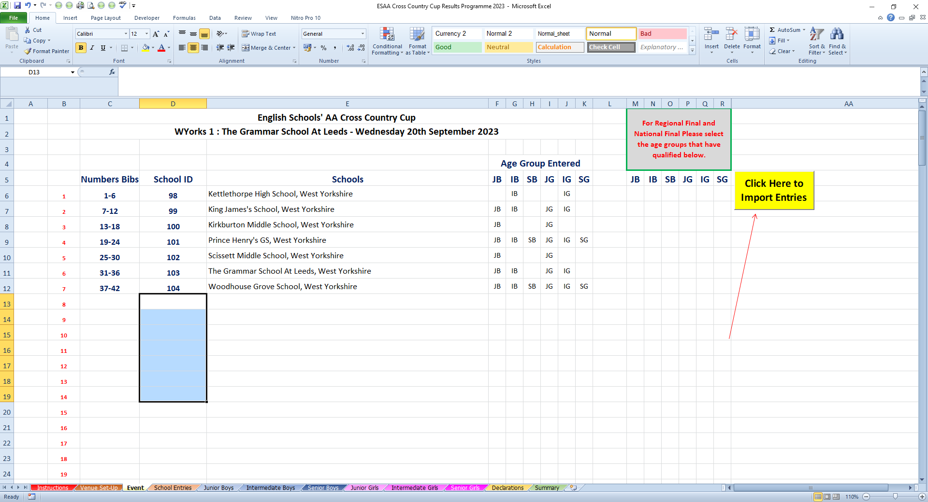

When you click on the yellow button you need to follow the instructions on the Microsoft Excel dialog box. Declarations need to be imported in the correct order.

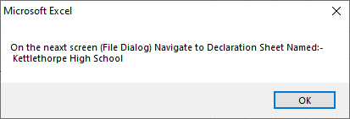

After importing the first school you will get another dialog box asking if you have more schools to import, by clicking on yes the process will continue until you are happy all schools are imported when they are the click no and the macro will stop running.

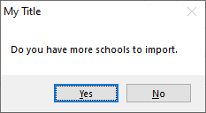

You are now all ready for your event so please save the programme.

