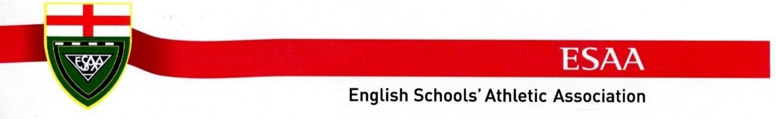
ESAA SCHOOLS CUP FINAL 2025
CHELMSFORD
ALL PRE ORDER EVENT T-SHIRTS WILL HAVE EVENT PRINT ON FRONT
ALL COMPETING SCHOOLS NAMES ON BACK
CUSTOMISE YOUR T SHIRT FOR £5 PER PRINT-PRE ORDER ONLY

FULL ESAA MERCHANDISE AVAILABLE AT
www.startfitness.co.uk

PLEASE COMPLETE THE ORDER FORM BELOW FOR GARMENTS FOR THE CUP FINAL AND
EMAIL TERRY@MOREMILE.CO.UK, FINNBRODIE@STARTFITNESS.CO.UK

TEL 0191 9173803 WHATSAPP 07895 387636

INVOICE WILL BE SENT WITH GOODS TO SCHOOL MINIMUM ORDER 5 ITEMS

ALL ORDERS PRE DELIVERY TO SCHOOL WILL BE DPD DELIVERY. PLEASE ORDER BEFORE 30TH JUNE


START FITNESS are the company appointed by the English Schools’ Athletic Association to supply official event merchandise for the ESAA Schools Cup Final CHELMSFORD

CONTACT NAME
MOBILE NUMBER
SCHOOL NAME
SCHOOL ADDRESS
SCHOOL POSTCODE
TOTAL NUMBER OF GARMENTS MINIMUM 5

Event Logo Reference For Items:


SHORT SLEEVE EVENT TEE SHIRT WILL HAVE ALL SCHOOL NAMES ON BACK
Image | Info | Name | RRP | Qty | 12yrs | 16yrs | S | M | L
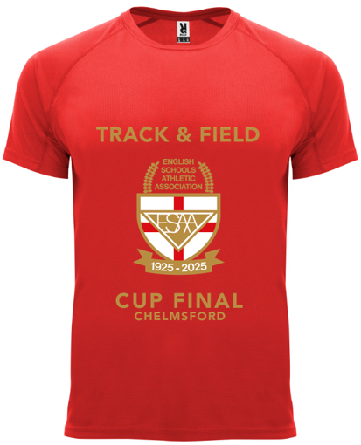 | RED | EVENT LOGO ON FRONT, ALL SCHOOL NAMES ON BACK | £15
Image | Info | Name | RRP | Qty | 12 yrs | 16yrs | S | M | L
 | ROYAL BLUE | EVENT LOGO ON FRONT, ALL SCHOOL NAMES ON BACK | £15
Image | Info | Name | RRP | Qty |  |  | S | M | L
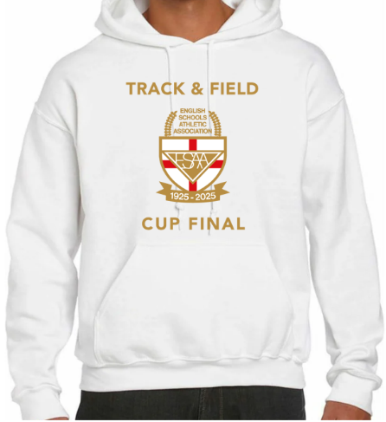 | EVENT HOODY, WHITE | WHITE HOODY | £20
Image | Info | Name | RRP | Qty |  |  | S | M | L
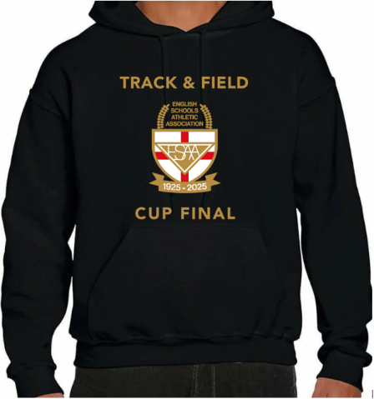 | EVENT HOODY, BLACK | BLACK HOODY | £20
Image | Info | Name | RRP | Qty |  | 16yrs | S | M | L
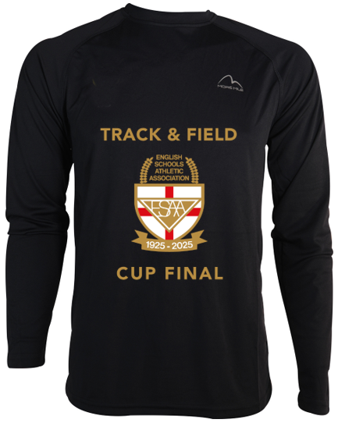 | BLACK LONG SLEEVE TOP | BLACK, LONG SLEEVE TOP | £20
Image | Info | Name | RRP | Qty | 12 yrs | 16yrs | S | M | L
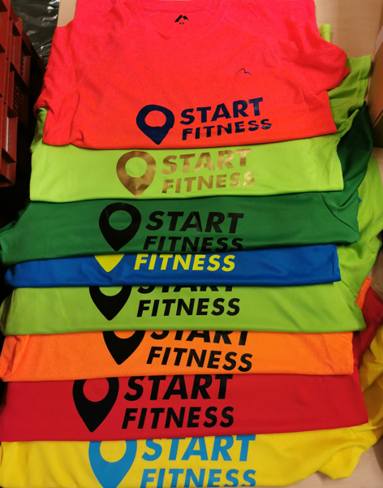 | SCHOOL EVENT SHIRT | SHORT SLEEVE TRAVEL TEE  EVENT LOGO ON FRONT  SCHOOL NAME ON BACK  MAX 2 LINES  UNDER SCHOOL NAME  PLEASE REQUEST COLOUR + SIZE | £12 |  | RED | BLUE | BLACK | WHITE | YELLOW
Image | Info | Name | RRP | Qty |  | 9-10yrs | 11-12yrs | 13-14yrs | 15-16yrs
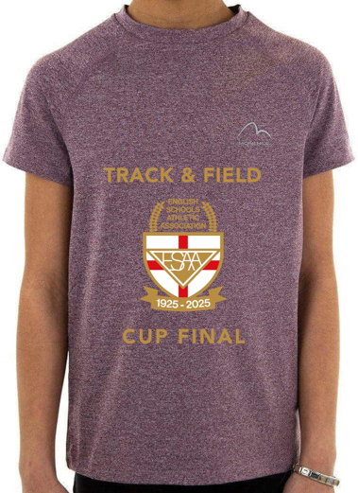 | SCHOOL EVENT SHIRT | SHORT SLEEVE TEE | £15
Image | Info | Name | RRP | Qty | 7-8 yrs | 9-10yrs | 11-12 yrs | 13-14yrs
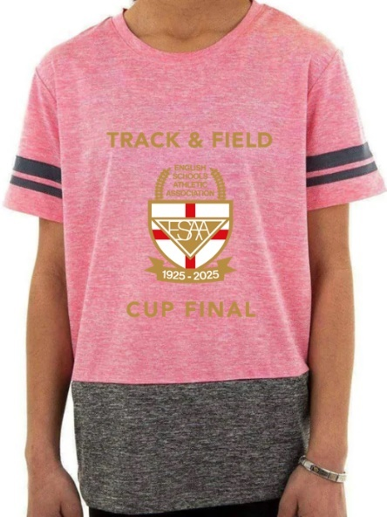 | SCHOOL EVENT SHIRT | SHORT SLEEVE TEE | £15
Image | Info | Name | RRP | Qty | 7-8 yrs | 9-10 yrs | 11-12 yrs | 13-14 yrs
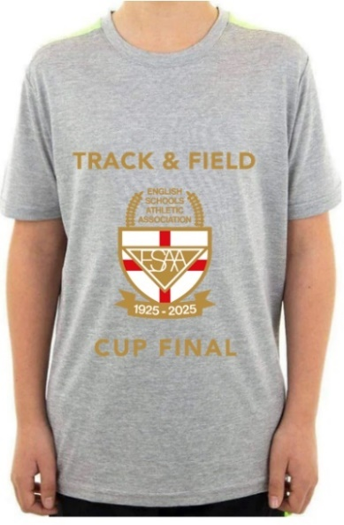 | SCHOOL EVENT SHIRT | SHORT SLEEVE TEE | £15
Image | Info | Name | RRP | Qty |  | 9-10 yrs | 11-12 yrs | 13-14yrs | 15-16yrs
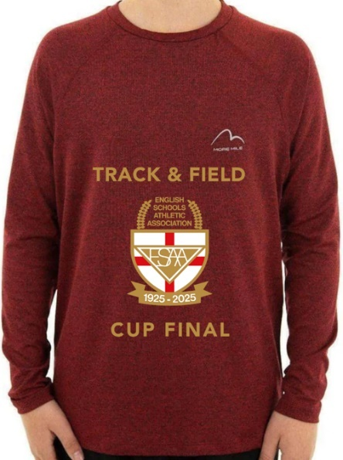 | SCHOOL EVENT SHIRT | LONG SLEEVE TOP | £20
Image | Info | Name | RRP | Qty |  | 9-10 yrs | 11-12 yrs | 13-14 yrs
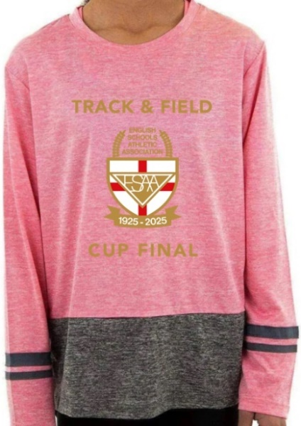 | SCHOOL EVENT SHIRT | LONG SLEEVE TOP | £20
Image | Info | Name | RRP | Qty |  |  | S | M | L
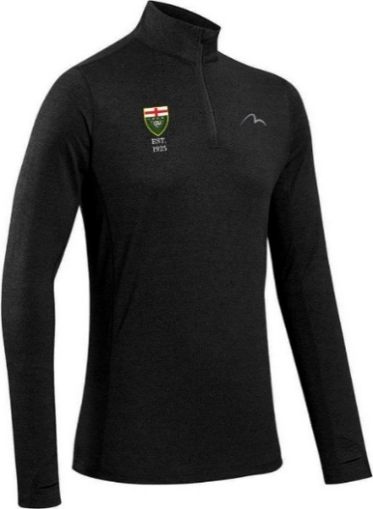 | BLACK | MORE MILE ¼ ZIP | £20
Image | Info | Name | RRP | Qty |  |  | S | M | L
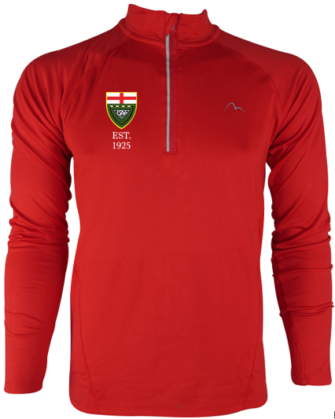 | RED | MORE MILE ¼ ZIP | £20
Image | Info | Name | RRP | Qty |  |  | S | M | L
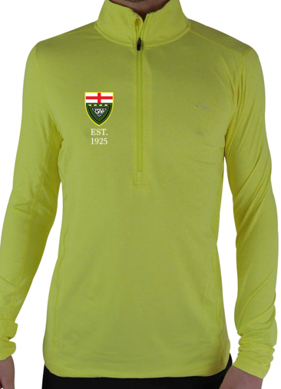 | YELLOW | MORE MILE ½ ZIP  SUN YELLOW | £20
Image | Info | Name | RRP | Qty |  | XS | S | M | L
 | 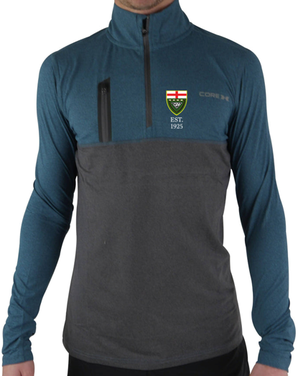  BLUE | COREX ¼ ZIP | £20
Image | Info | Name | RRP | Qty
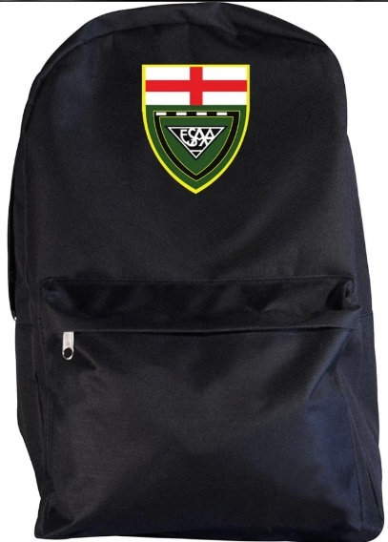 | ESAA BACK PACK | BLACK | £15

